Nevada FFA Foundation
Thank you to our 2024 Convention & Competitive Event Sponsors

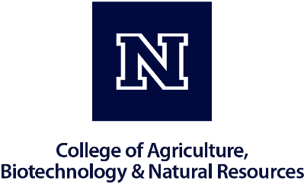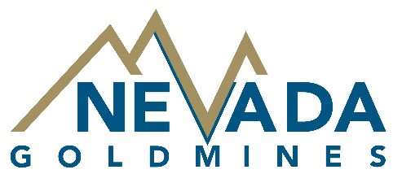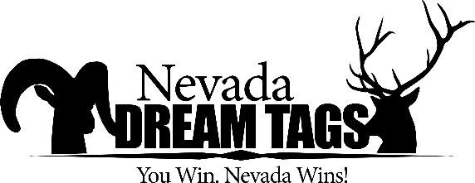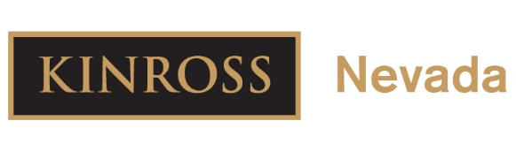

Title & Platinum Contributors - $5,000+
College of Agriculture, Biotechnology & Natural Resources - Host & Sponsor
Nevada Gold Mines - Convention Title Sponsor
American AgCredit- Star Partner, Convention & Competitive Events, Scholarship, Farm Business Management, Marketing Plan, Prepared Public Speaking, Star State Agribusiness
Dream Tags -Environmental & Natural Resources
Kinross Mines - Ag. Technology & Mechanical Systems

Platinum Contributors - $2,500+

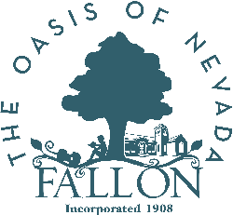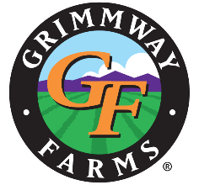

City of Fallon, Mayor Ken Tedford & Fallon City Council-Parliamentary Procedure, Poultry Evaluation, Best Informed Greenhand
Grimmway Foods- Convention & Competitive Events

Platinum Contributors - $1,000+

John & Amanda Hutchings, Fall River Brewing- Convention & Competitive Events
Dairy Farmers of America (DFA)- Convention & Competitive Events
Nevada Dairy Farmers-Milk Quality & Products
Nevada Dept. of Agriculture- Convention & Competitive Events
Rocky Mountain Agronomics- Convention & Competitive Events
Troy & Meagan Jordan- Convention & Competitive Events

Diamond Contributors - $500-$999
Anderson Dairy-Milk Quality & Products
Jessy and Diego Lozada*- Convention & Competitive Events
Bob Oakden-Creed Speaking, Floriculture, Prepared Public Speaking
In honor of Dennis Digenan (Thomas Klein)*- Convention & Competitive Events
Agri Beef Company-Meats Evaluation & Technology
Anonymous*- Convention & Competitive Events
Daniel & Anne Fagundes- Convention & Competitive Events
Gallagher Ford- Convention & Competitive Events
Cannon Ranch-Host of Soils & Homesite, Rangeland Management
Rail City Garden Center & Master Gardeners-Host of Nursery Landscape
Sparks Florist- Host of Floriculture
UNR Equestrian Center-Host of Horse
Western Nevada College-Host of Ag. Technology & Mechanical Systems
WolfPack Meats-Host of Meats Evaluation & Technology
Hunter Drost: Edward Jones*- Convention & Competitive Events
Julene Smith*- Convention & Competitive Events
Nevada Cattlemen's Assoc.-Meats Evaluation & Technology
Pauline Inchauspe, Silver Creek Ranch- Convention & Competitive Events
Plumas Bank- Convention & Competitive Events
Steve & Leslie Zimmerman*- Convention & Competitive Events
Ty & Sherri Nebe-Floriculture
Wells Auto & Hardware-Agricultural Sales, Extemporaneous Speaking

Gold Contributors - $250-$499
Don & Jolene Noorda, High Desert Irrigation, Inc.*-Farm Business Management
Gus & April Wright-Conduct of Chapter Meetings
White Pine Conservation District-Soils & Homesite, Rangeland Management
Barnes Ranches, Inc.-Livestock Evaluation

Gold Contributors - $250-$499 continued
Blane Merkley*- Convention & Competitive Events
Gary Aldax-Marketing Plan
Richard & Ellen Olson*- Convention & Competitive Events
Smith Ranch, Julian & Joanna Smith*- Convention & Competitive Events
Tom & Kelly Barnes*- Convention & Competitive Events

Silver Contributors - $100-$249
3 QS Cattle Series, LLC, James & Melinda Filippini-Horse Evaluation
Amber Smyer*- Convention & Competitive Events
Andrea & Jeremy Nevin*- Convention & Competitive Events
Anne G. Willard & John L. Swingen Jr.-Floriculture
Beverly Conley*- Convention & Competitive Events
Capital Dumpsters LLC*- Convention & Competitive Events
Freeport Freight Systems Inc.*- Convention & Competitive Events
In honor of J. Cody Sanders (Catelyn Sanders)*- Convention & Competitive Events
JJ Goicoechea*- Convention & Competitive Events
Molly Hunsaker*- Convention & Competitive Events
Patty Julian-State Star Awards - Production Ag & Agriscience
Carol Herl*- Convention & Competitive Events
Curt & Lynda Jordan-Parliamentary Procedure
Jim Barbee & Heather Dye*-Environmental & Natural Resources
McMullen, McPhee & Co. LLC-Prepared Public Speaking & Creed Speaking
Zach & Shelly Bunyard*- Convention & Competitive Events
A&K Earth Movers, Inc.- Convention & Competitive Events
Anonymous*- Convention & Competitive Events
Anonymous*- Convention & Competitive Events
Holly Merritt*- Convention & Competitive Events
In honor of J. Cody Sanders (Casey Sanders)*- Convention & Competitive Events
Katie (Klein) Jarstad*- Convention & Competitive Events

Silver Contributors - $100-$249 continued
Ken & Rebecca Wellnitz- Convention & Competitive Events
Tamra Williams*- Convention & Competitive Events

Bronze Contributors - $51-$99
Gabriella Minoletti*- Convention & Competitive Events

Friend of FFA - Contributions up to $50
Barnes*- Convention & Competitive Events
Brian Sheldon*- Convention & Competitive Events
Caitlyn Dock*- Convention & Competitive Events
Garrett Hylton*- Convention & Competitive Events
In honor of Fred Garrett and Shelly Garrett Petersen (Sally Hylton)*- Convention & Competitive Events
Kristen Kirkpatrick*- Convention & Competitive Events
Lander Smith*- Convention & Competitive Events
Lisa Bertok*- Convention & Competitive Events
Morgan Noorda*- Convention & Competitive Events
Ruby Uhart*- Convention & Competitive Events
S7 Livestock L.L.C, Josh Smith*- Convention & Competitive Events
Selena & Fred Minoletti*- Convention & Competitive Events
Shawn & Jennifer Ruedy*- Convention & Competitive Events
Sonny Lopez Hernandez*- Convention & Competitive Events
William Fousnought*- Convention & Competitive Events
Irma Davila*- Convention & Competitive Events
Anonymous*- Convention & Competitive Events
Connie Drost*- Convention & Competitive Events
Danica Lopez*- Convention & Competitive Events
Jackie Kingston*- Convention & Competitive Events
Simone Weaver*- Convention & Competitive Events

